# Understanding Materials and Textures

Drawing materials effectively bridges technical skills with how a space affects our senses. This section builds on your professional hand drawing abilities to help you document and showcase materials using various techniques. These skills will boost how you communicate design ideas, craft professional presentations, and prepare you for color theory in upcoming modules. Mastering material qualities gives you a powerful communication tool you'll depend on throughout your design career.



Fig.1 (cottonbro studio on [Pexels](https://www.pexels.com/photo/7505170/), 2025) Professional material documentation combining physical samples with hand-drawn texture studies

## 1. Material Basics

### Common Material Symbols and Conventions

Interior designers rely on standard symbols to efficiently represent materials in technical drawings:

* **Wood**: Parallel lines showing grain direction with occasional ovals for knots
* **Brick/Stone**: Staggered rectangular patterns or irregular organic shapes
* **Tile**: Grid patterns with consistent spacing for grout lines
* **Fabric**: Subtle cross-hatching or flowing lines suggesting texture
* **Glass/Metal**: Minimal lines with strategic highlights for reflective surfaces

These symbols aren't random—they're simplified versions of how materials actually appear. They build directly on the architectural symbols from previous lessons, now focusing on surface qualities.

**Try This as you build your professional toolkit:** Create a personal reference sheet with 5cm squares showing standard symbols for six common interior materials. This will serve as a quick reference guide for future projects. Label each symbol with typical applications in interiors.

### Texture Drawing Techniques

Now that we've covered basic symbols, let's dive into how texture brings these representations to life. While symbols tell us what a material is, texture techniques help convey how it might feel to touch—a crucial quality in interior design where sensory experience matters.

Texture adds life to drawings by suggesting tactile qualities:

* **Line Weight Variation**: Adjust your pencil pressure to create depth—lighter lines for recessed areas, bolder lines for raised surfaces
* **Stippling**: Use dots of varying density to show rough or granular surfaces
* **Hatching/Cross-Hatching**: Create parallel or intersecting lines for shadow and texture
* **Directional Strokes**: Align your marks with the natural grain or pattern of the material

Take a moment to examine real materials before drawing them. The texture techniques you're learning now directly apply the line control skills from your foundation drawing lessons.

### Pattern Representation

Beyond texture, many interior materials feature distinctive patterns that need specific drawing approaches. Whether you're showing wallpaper, upholstery fabric, or decorative tiles, knowing how to simplify and capture patterns efficiently counts for professional documentation.

When drawing patterns in materials:

1. Identify the basic repeating unit
2. Create a light grid to make sure spacing stays consistent
3. Simplify complex patterns to their key elements
4. Keep scale appropriate to your drawing size

**Common Mistake**: Many beginners try to draw every detail of complex patterns. Instead, focus on capturing the pattern's character and how it fits into your overall drawing.

## 2. Drawing Application

### Material Indication Methods

With a solid understanding of material symbols and texture techniques, you'll need to apply these skills differently across various drawing types. Each drawing format serves a specific purpose in the design process, requiring thoughtful adaptation of your material representation approach.

Adapt material representations based on drawing type:

* **Plan Views**: Use simplified symbols that don't overwhelm other information
* **Sections**: Show material depth and layering with appropriate symbols
* **Elevations**: Demonstrate surface appearance with more detailed textures
* **Details**: Focus on material transitions and connections

Match your level of detail to your drawing's purpose—simpler for concept sketches, more detailed for client presentations.

**Try This when exploring scale relationships in your drawings:** Pick a corner of a room and draw it three times at different scales (1:50, 1:20, 1:5). Notice how your material indication detail needs to shift with each scale. Jot down which scale feels most natural for your drawing style.

### Shading Techniques for Material Realism

While symbols and textures communicate basic properties of materials, shading truly brings your drawings to life. Getting comfortable with shading techniques allows you to show not just what materials are present, but how they interact with light and space—creating drawings that feel three-dimensional and authentic.

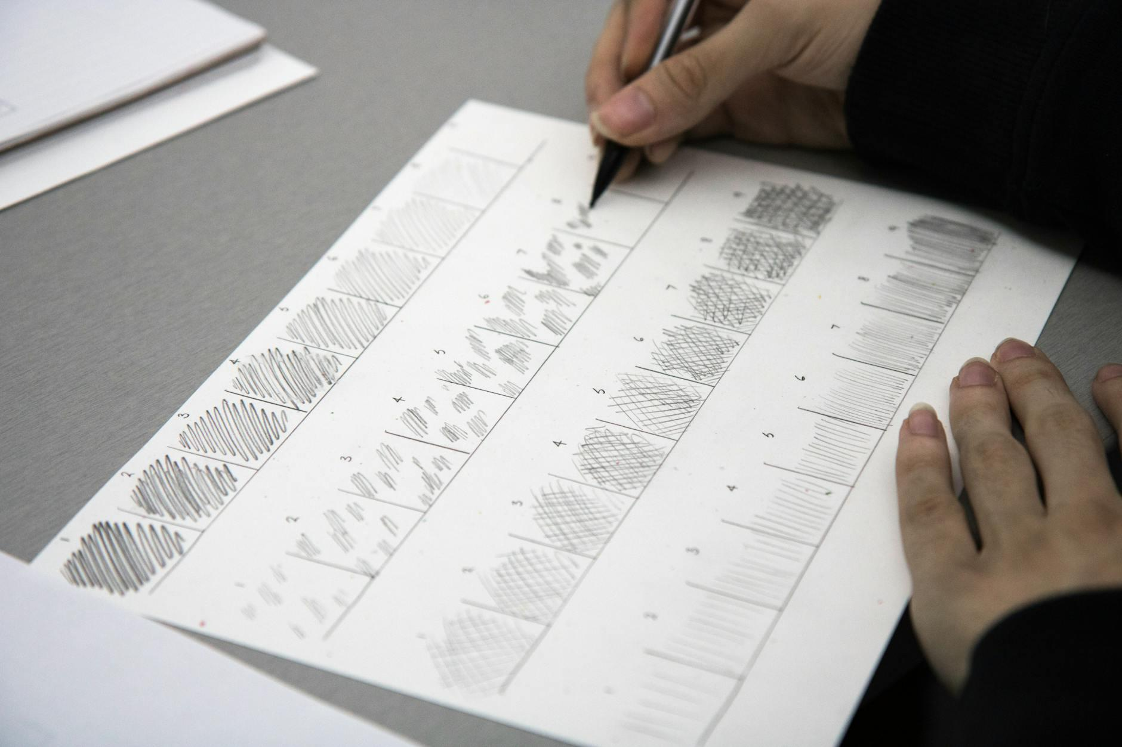

Fig.2 (Roxanne Minnish on [Pexels](https://www.pexels.com/photo/7963968/), 2025) Shading techniques demonstrating material differences between wood flooring, fabric upholstery, and glass surfaces

Good shading creates the impression of three-dimensional form and material qualities:

* **Graduated Shading**: Create smooth transitions from light to dark for curved surfaces
* **Cast Shadows**: Add small, precise shadows where materials meet to create depth
* **Reflective Highlights**: Leave strategic areas blank to suggest glossy or polished surfaces
* **Texture Contrast**: Vary your shading technique between different materials to highlight their differences

Remember that your goal is clear communication, not photorealism. Suggestion often works better than exhaustive detail.

**Over to you:**

1. Which texture drawing technique do you find trickiest to execute, and how might you tweak your approach to improve?
2. Think about a specific interior space you know well. How would you decide which materials need the most detailed representation in a client presentation drawing versus a technical drawing?

## 3. Documentation Methods

### Visual Documentation Techniques for Materials

Beyond drawing skills, professional designers need systematic approaches to documenting materials. This documentation forms the backbone of your design process, making sure you specify accurately and communicate consistently with clients and contractors throughout a project.

Good material documentation is vital for interior designers:

1. **Lighting Observation**: Note how materials look under different lighting conditions
2. **Scale Reference**: Include a ruler or familiar object to show size in your documentation
3. **Multiple Angles**: Document materials from different perspectives to understand surface qualities
4. **Context**: When possible, capture materials in their intended environment

These visual references will become valuable assets for your material library and design presentations.

### Digital Documentation Basics

While hand drawing remains fundamental, adding basic digital documentation enhances your professional toolkit. Even simple digital techniques can dramatically improve how you capture, sort, and share material information with clients and collaborators.

Simple digital approaches improve material documentation:

* **Selective Focus**: Concentrate on the most representative portions of a material
* **Detail Capture**: Make sure texture details are clearly visible
* **Color Accuracy**: Document colors as they appear in their intended setting
* **Organization**: Create a consistent file naming system for your digital material library

You don't need high-level technical skills—even basic digital documentation using simple tools can significantly improve your material reference system.

### Creating a Material Reference System

As your knowledge of materials grows, you'll need an organized system to manage this information. Professional designers develop personalized approaches that combine physical samples, drawings, and digital documentation—creating a valuable resource that evolves throughout their careers.

Develop a systematic approach to organizing material information:

1. Create a physical sample collection with consistent mounting and labelling
2. Maintain a digital library with categories (wood, stone, textiles, etc.)
3. Include specification details alongside visual documentation
4. Use consistent formats for easy comparison

This organized approach to material documentation will serve you well throughout your design career.

## Equipping You for HNC Success

The material representation skills you've developed form a critical foundation for your HNC studies, enabling professional communication of design concepts through accurate, expressive documentation of interior elements.